The Final Application

*CIT 255*

Sprint 1

Terri Wilkinson

11/5/2017

The Final Application

CIT 255

Contents

Overview 2

#### Overview

The CD Library application will provide the user with a tool that will hold a

song library in a format that can perform basic CRUD operations. With this tool the user can create, read, update, and delete files. The user will also have the ability to sort through the various attributes in the files using a query to bring back selected results to view. The application also provides the user with the ability to add ratings to song choices that can be used as a filter.

#### User Stories

##### User Story 1

To be able to begin application with a basic list of songs already created

##### User Story 2

To be able to create a new song object and add to records

##### User Story 3

To be able to delete a song from records

##### User Story 4

To be able to sort through records by artist, title, genre, or rating

##### User Story 5

To be able to add user ratings to songs

##### User Story 6

To be able to update existing song records

##### User Story 7

To be able to list all song records

##### User Story 8

To be able to exit application at any time

##### User Story 9

To have a simple, easy to follow platform with clear instructions

#### Entity Diagram

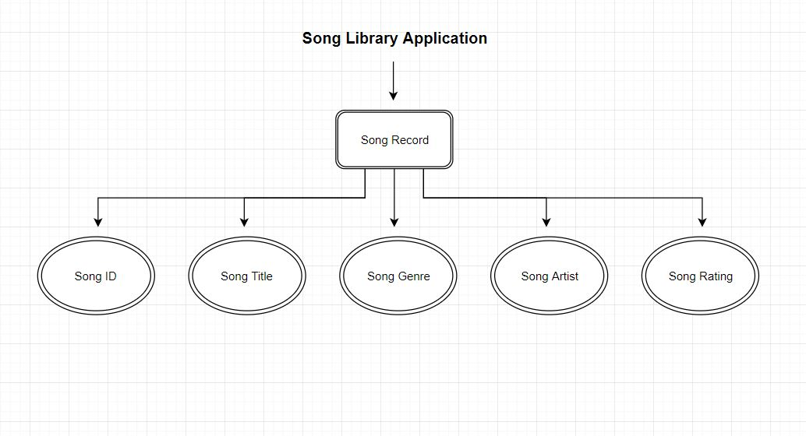

#### Wireframes

##### Welcome Screen

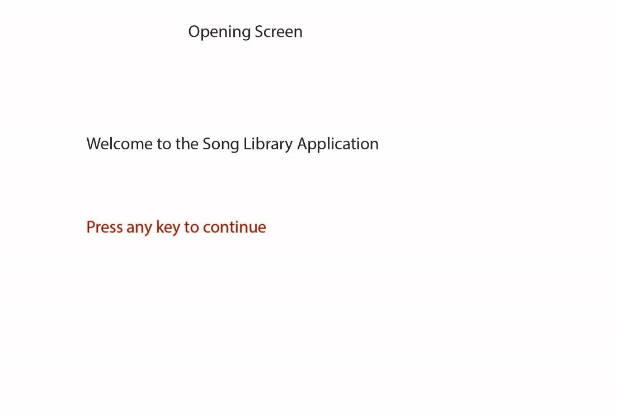

##### Menu

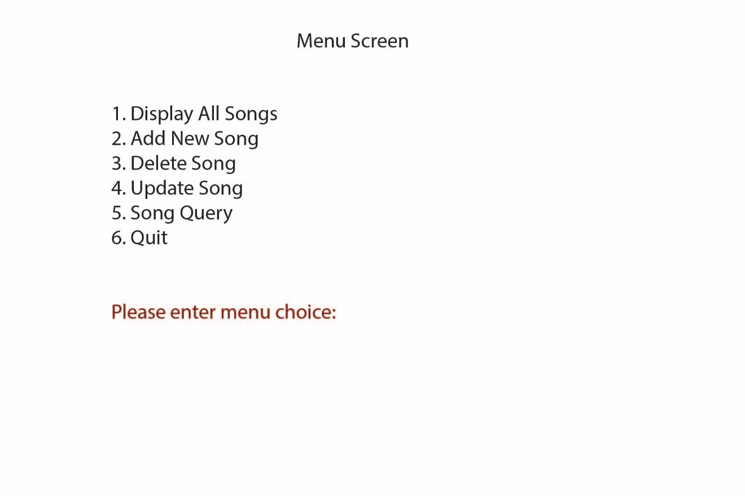

##### Song List

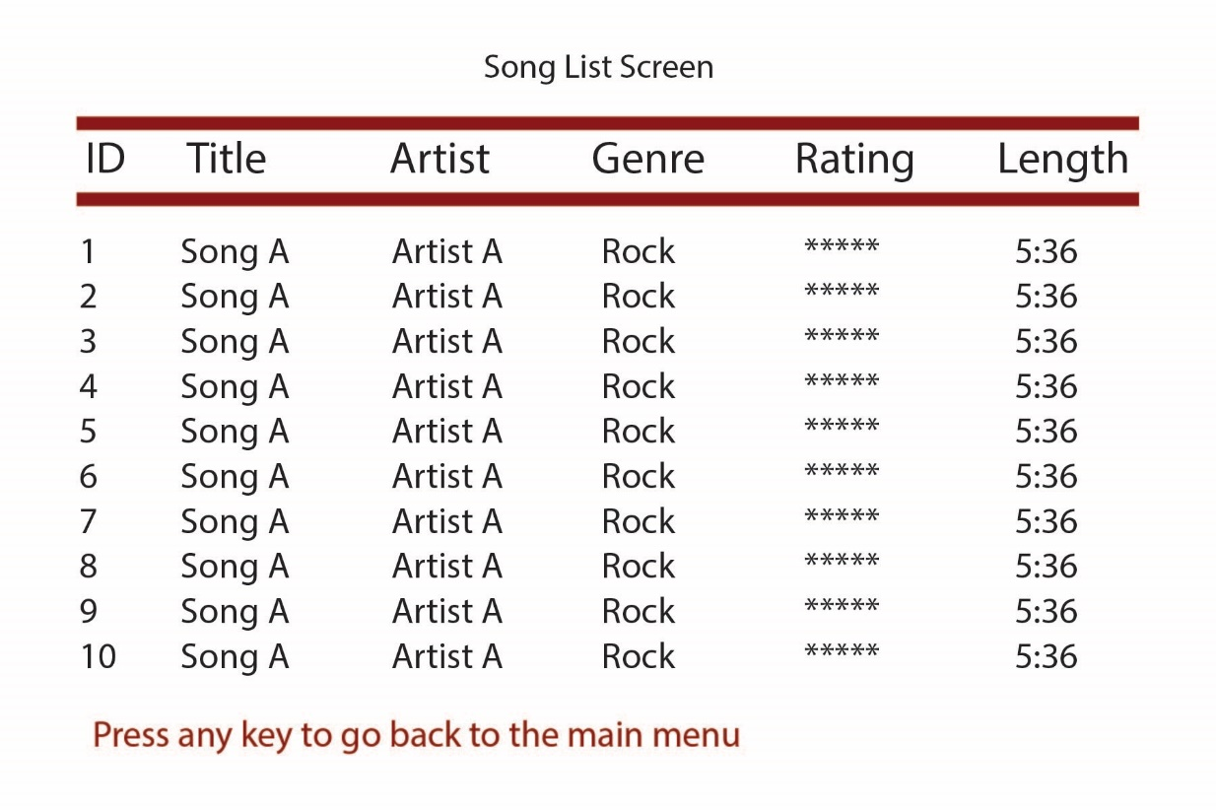

##### New Song Title

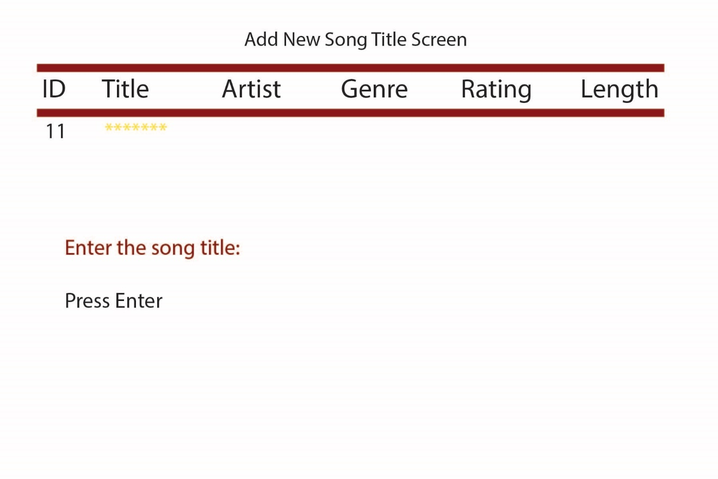

##### New Song Artist

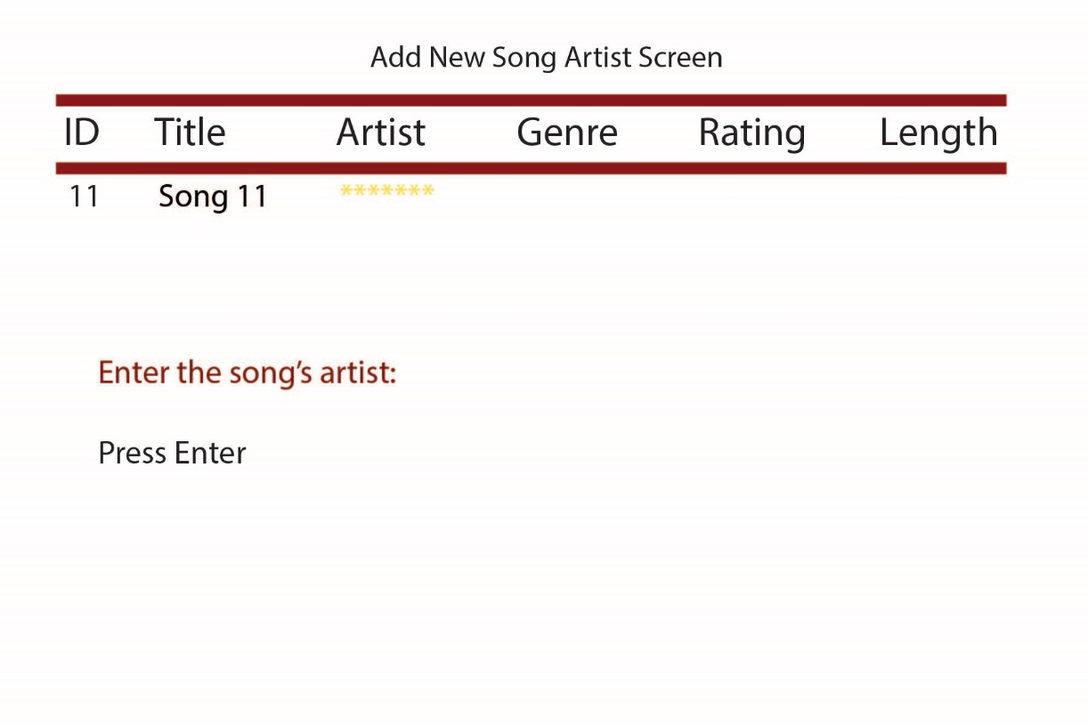

##### New Song Genre

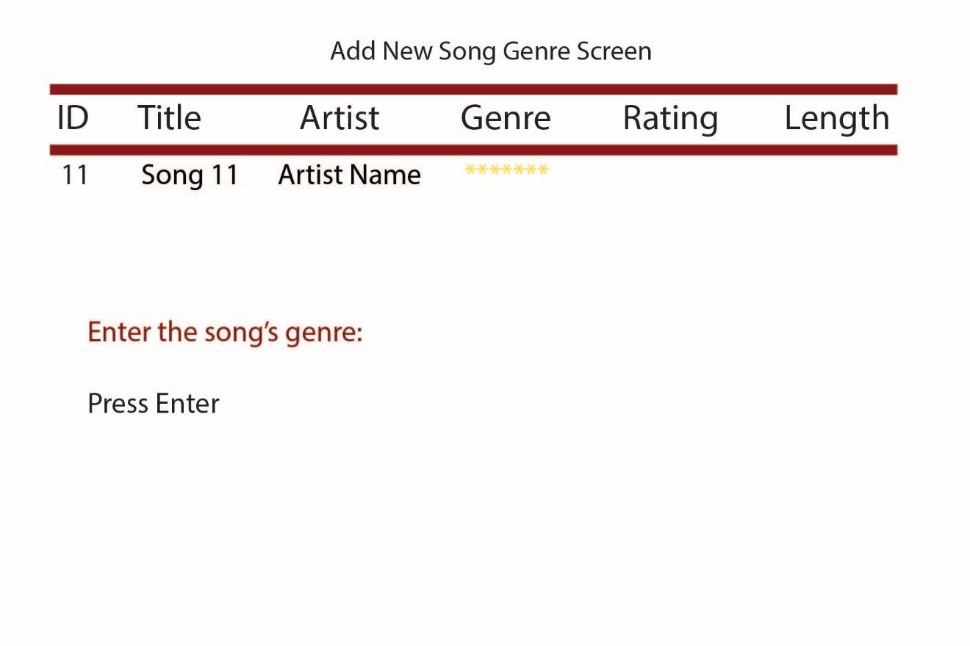

##### New Song Rating

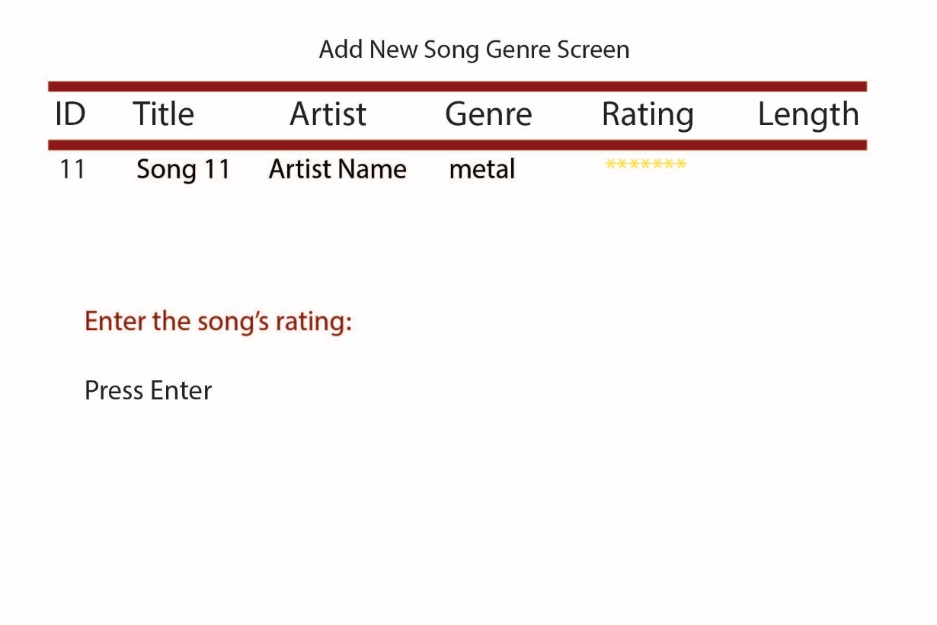

##### New Song Length

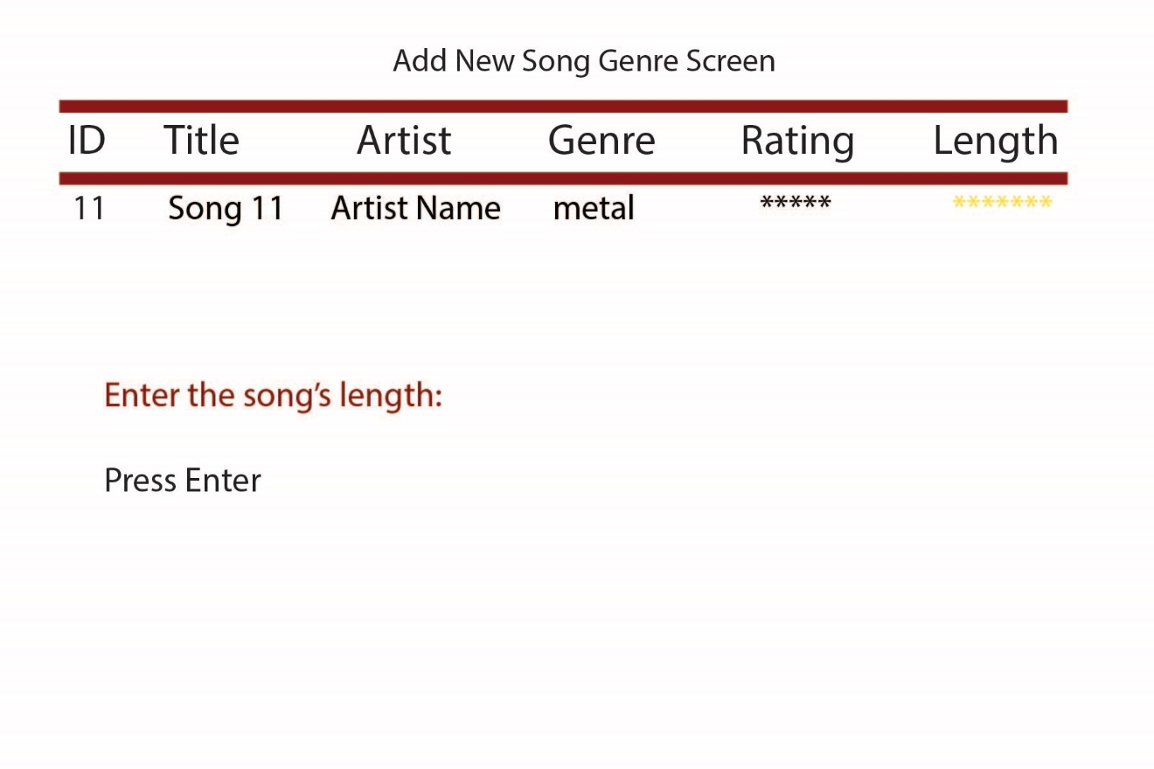

##### Song Added Confirmation

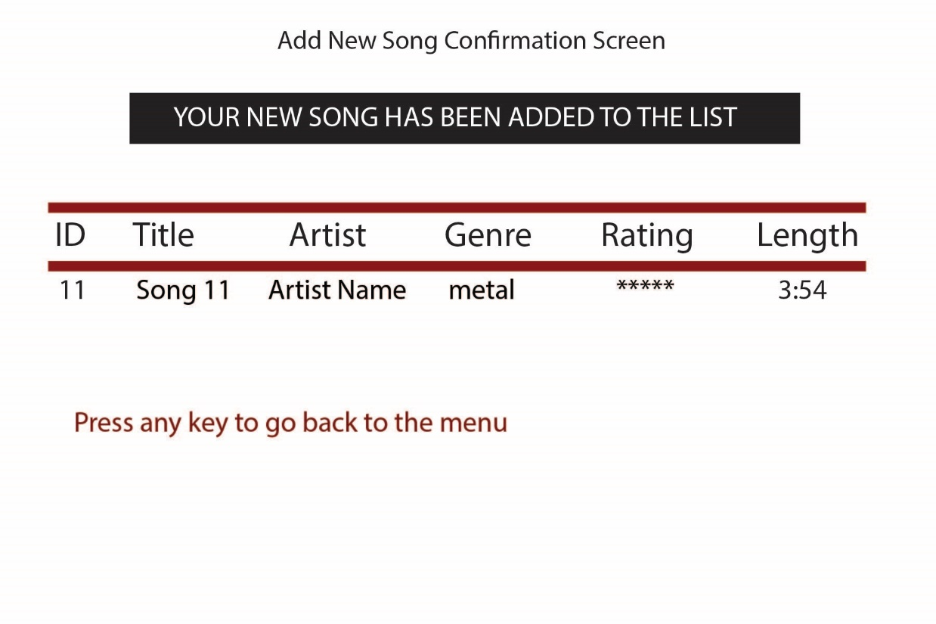

##### Delete Song

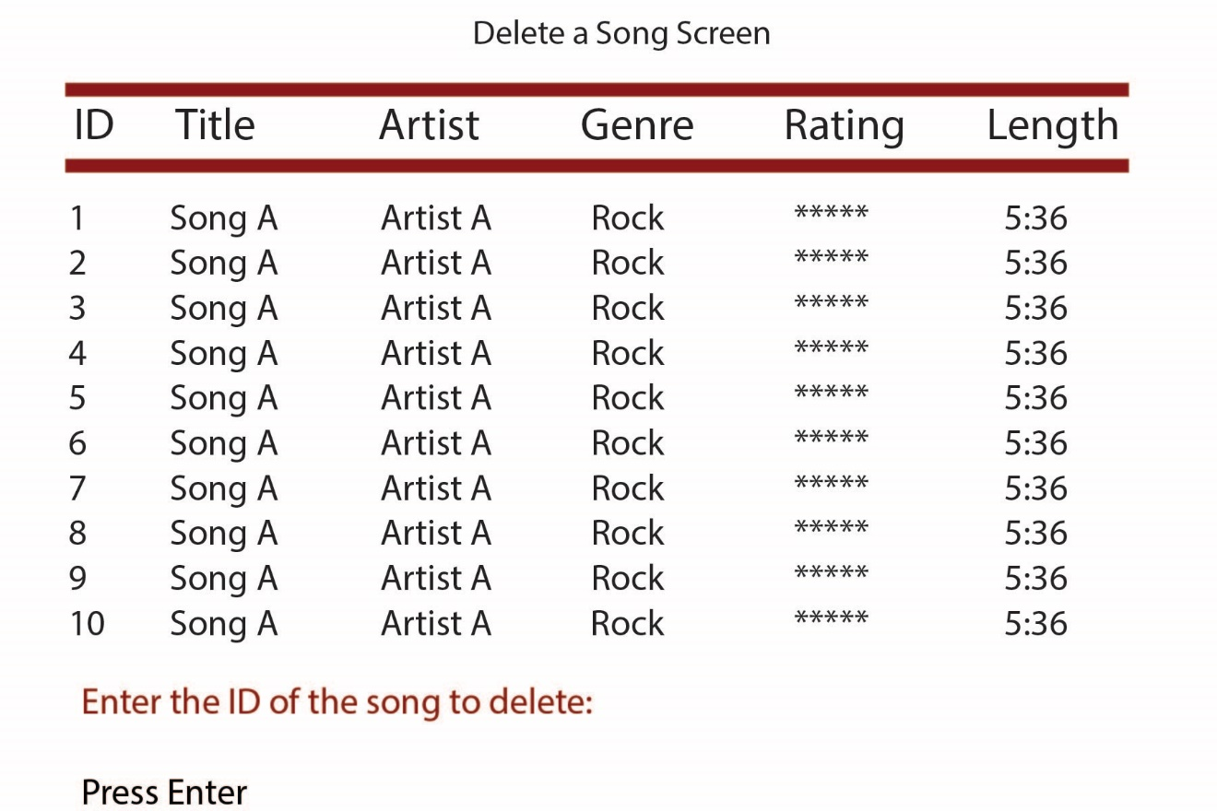

##### Delete Confirmation

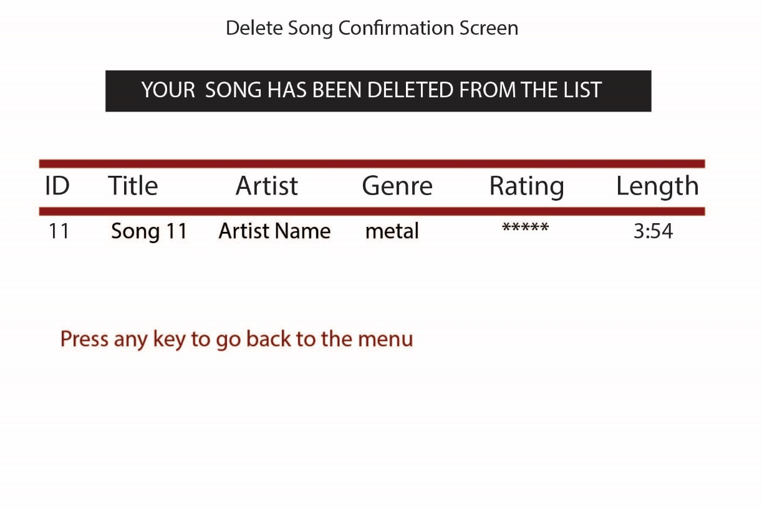

##### Update Song Choice

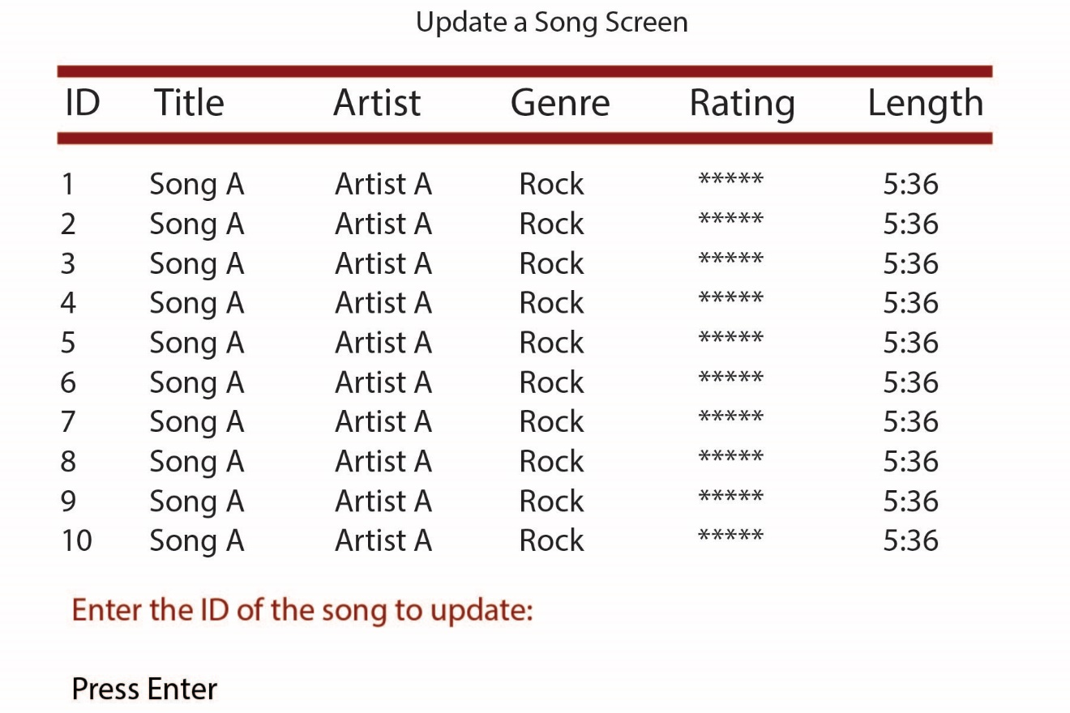

##### Choose Update Attribute

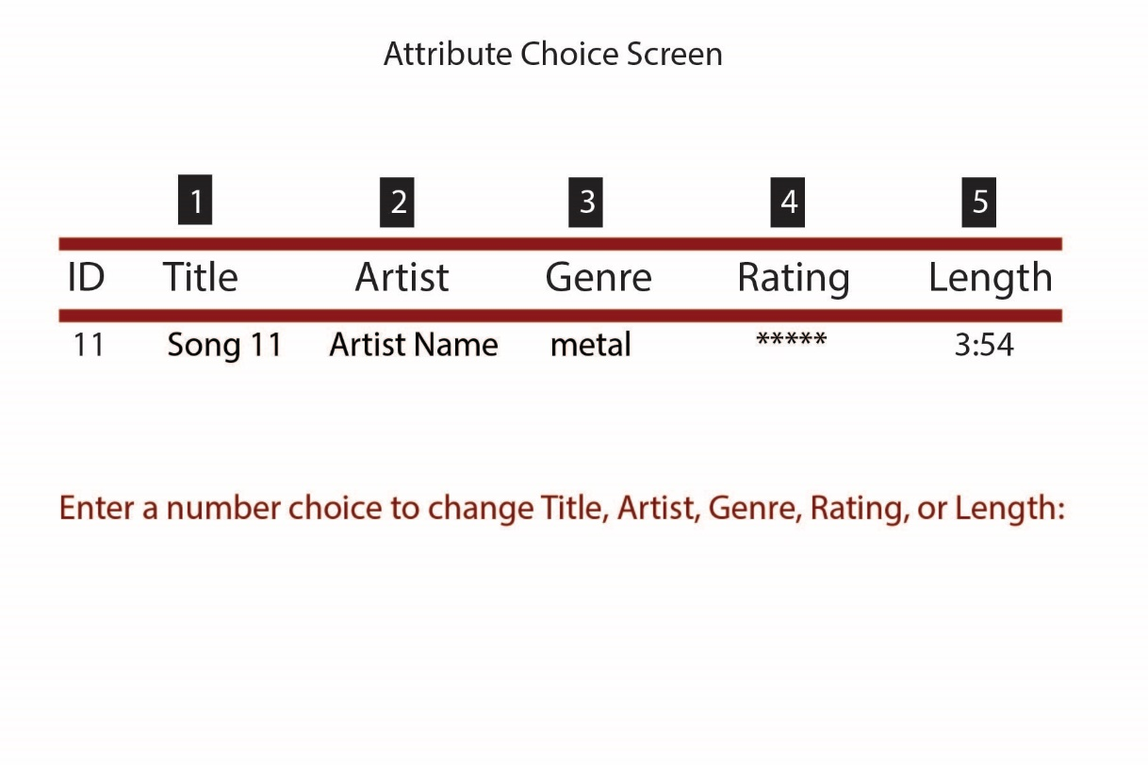

##### Update Song Title

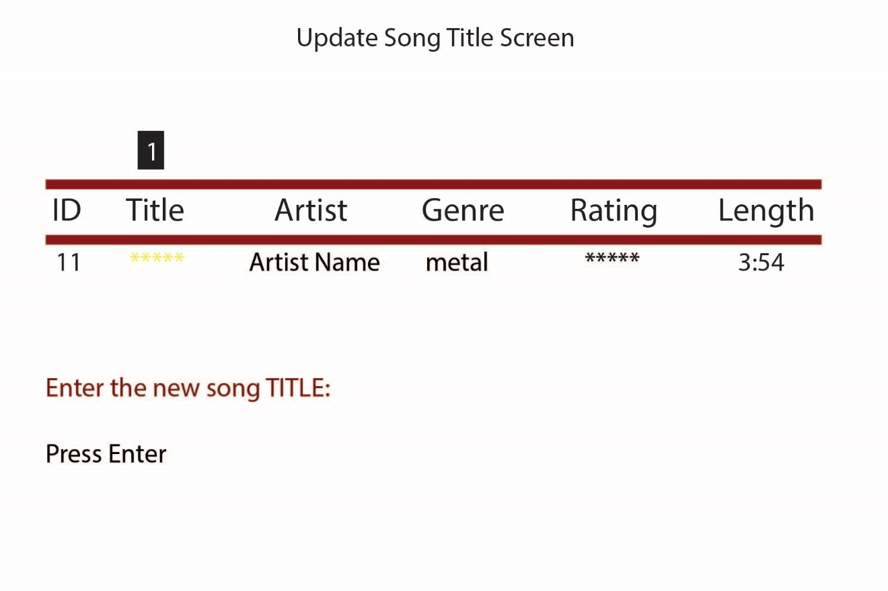

##### Update Song Artist

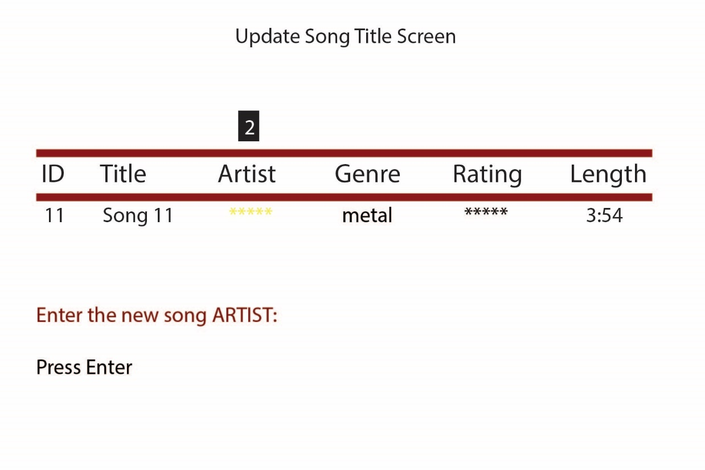

##### Update Song Genre

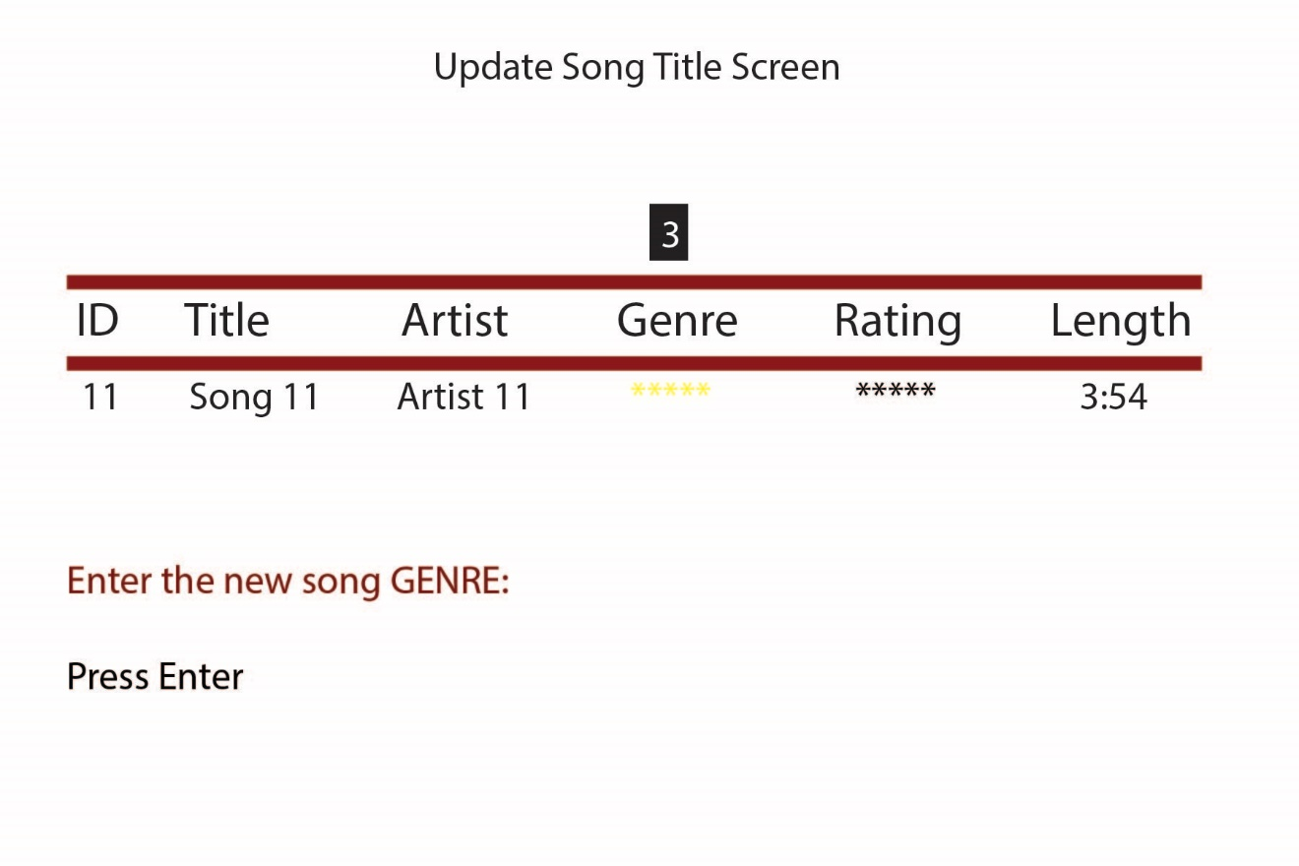

##### Update Song Rating

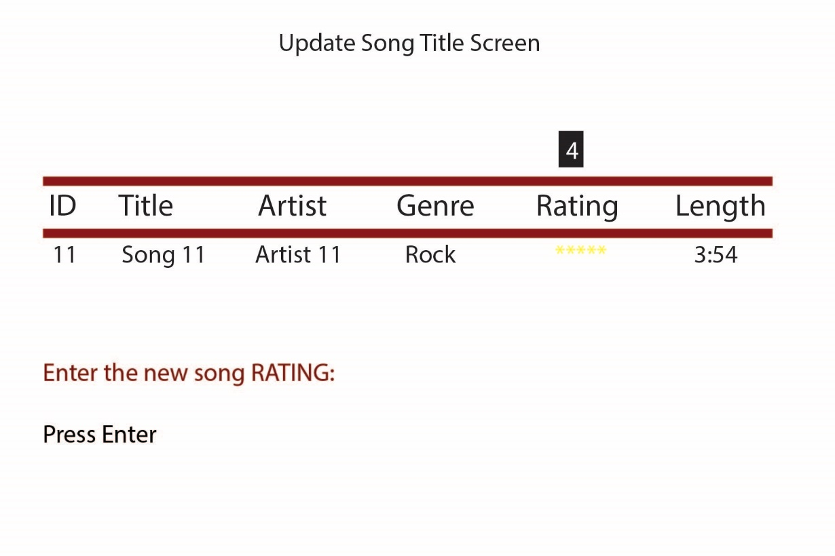

##### Update Song Length

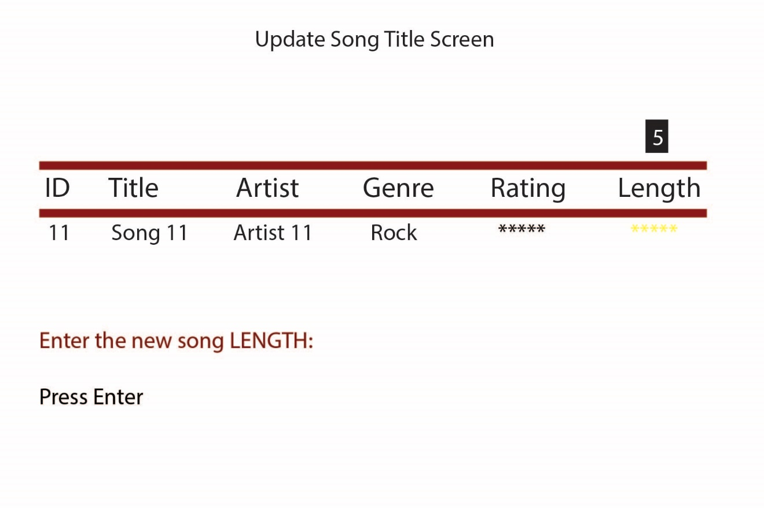

##### Song Update Confirmation

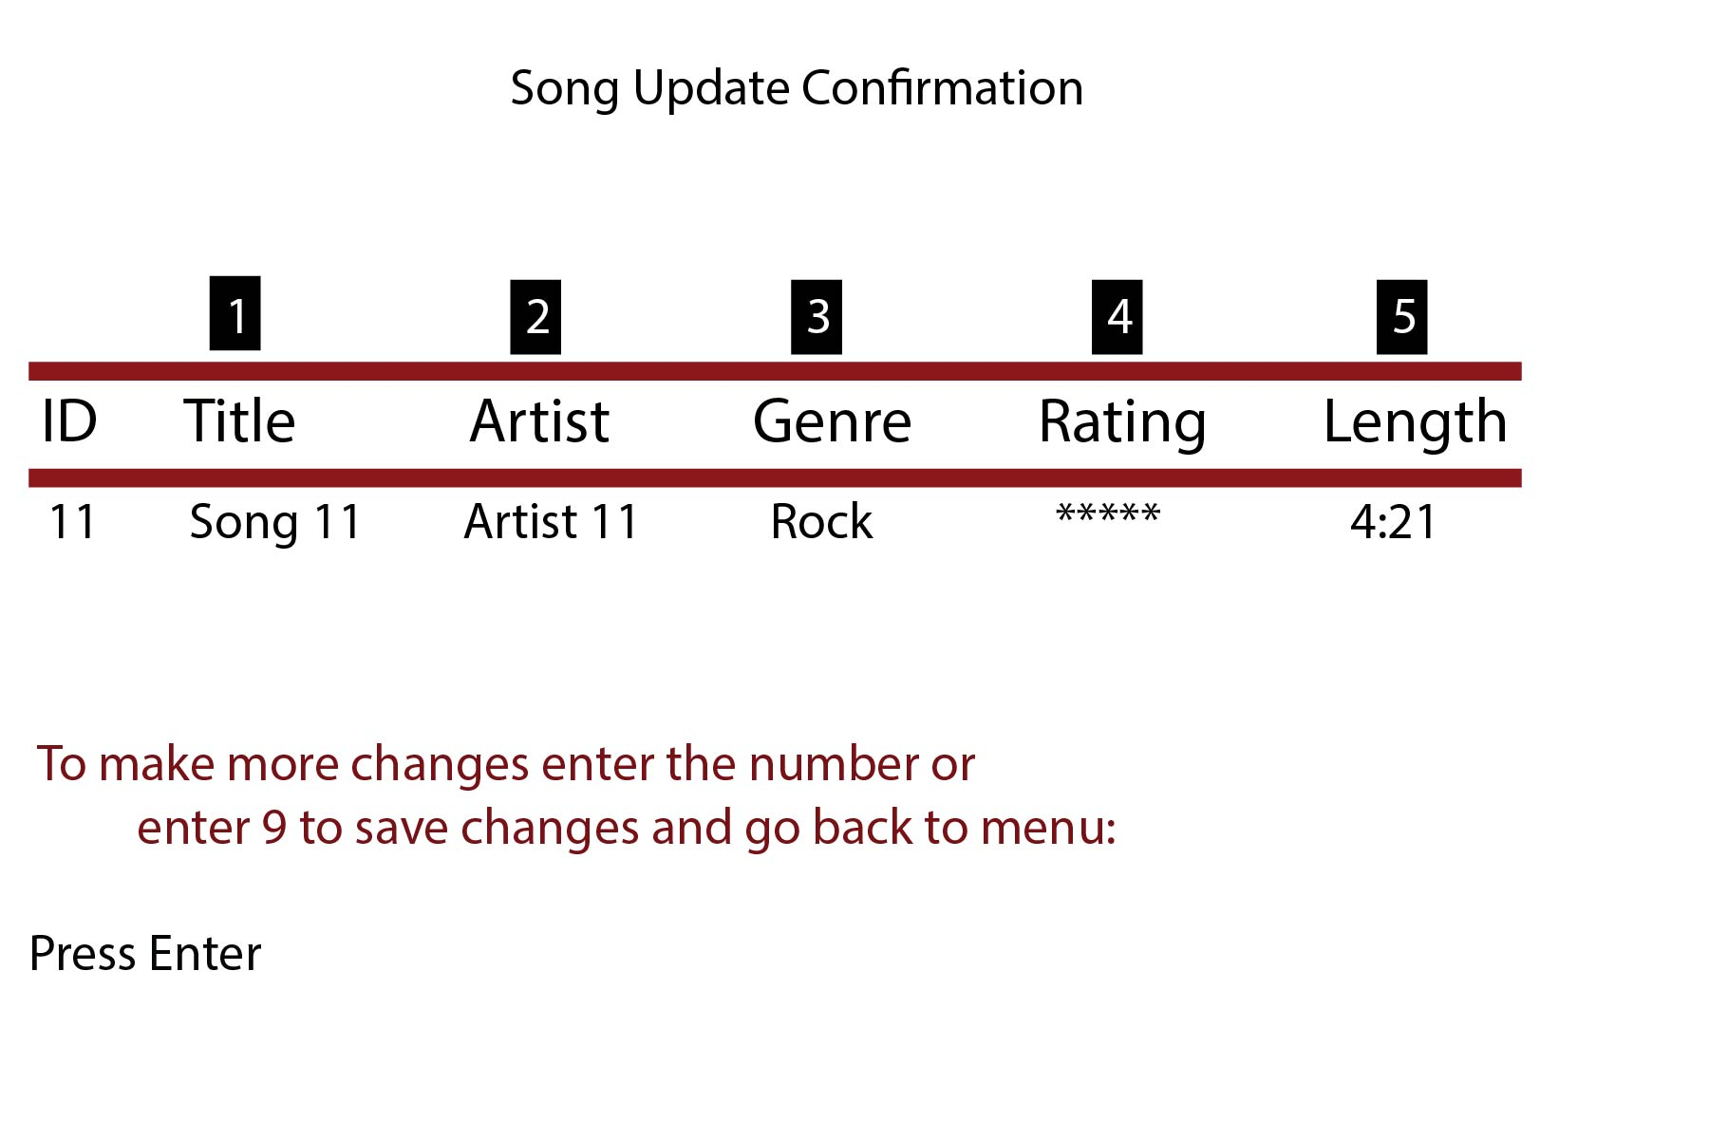

##### Song Query

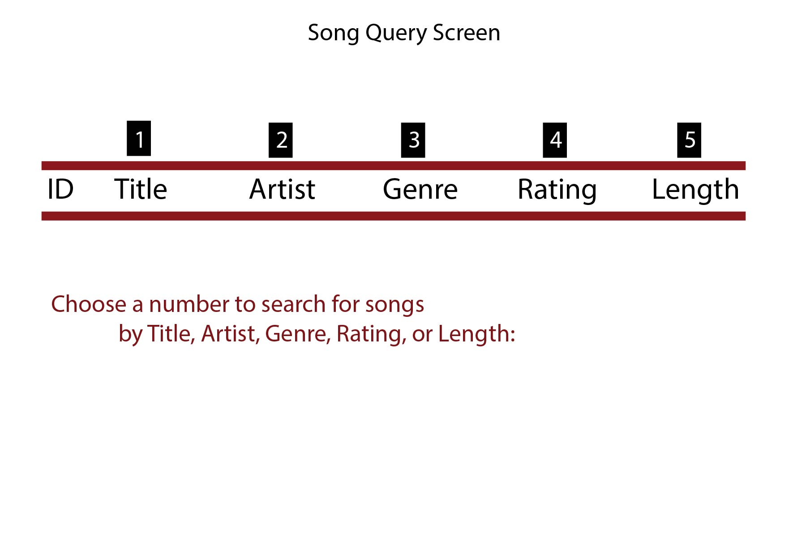

##### Song Query Results

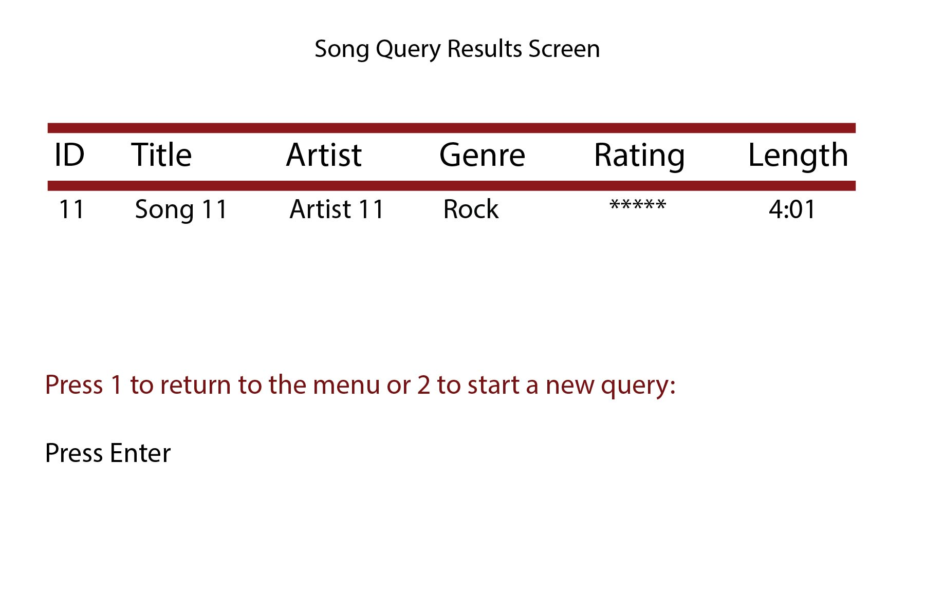

##### Exit Screen

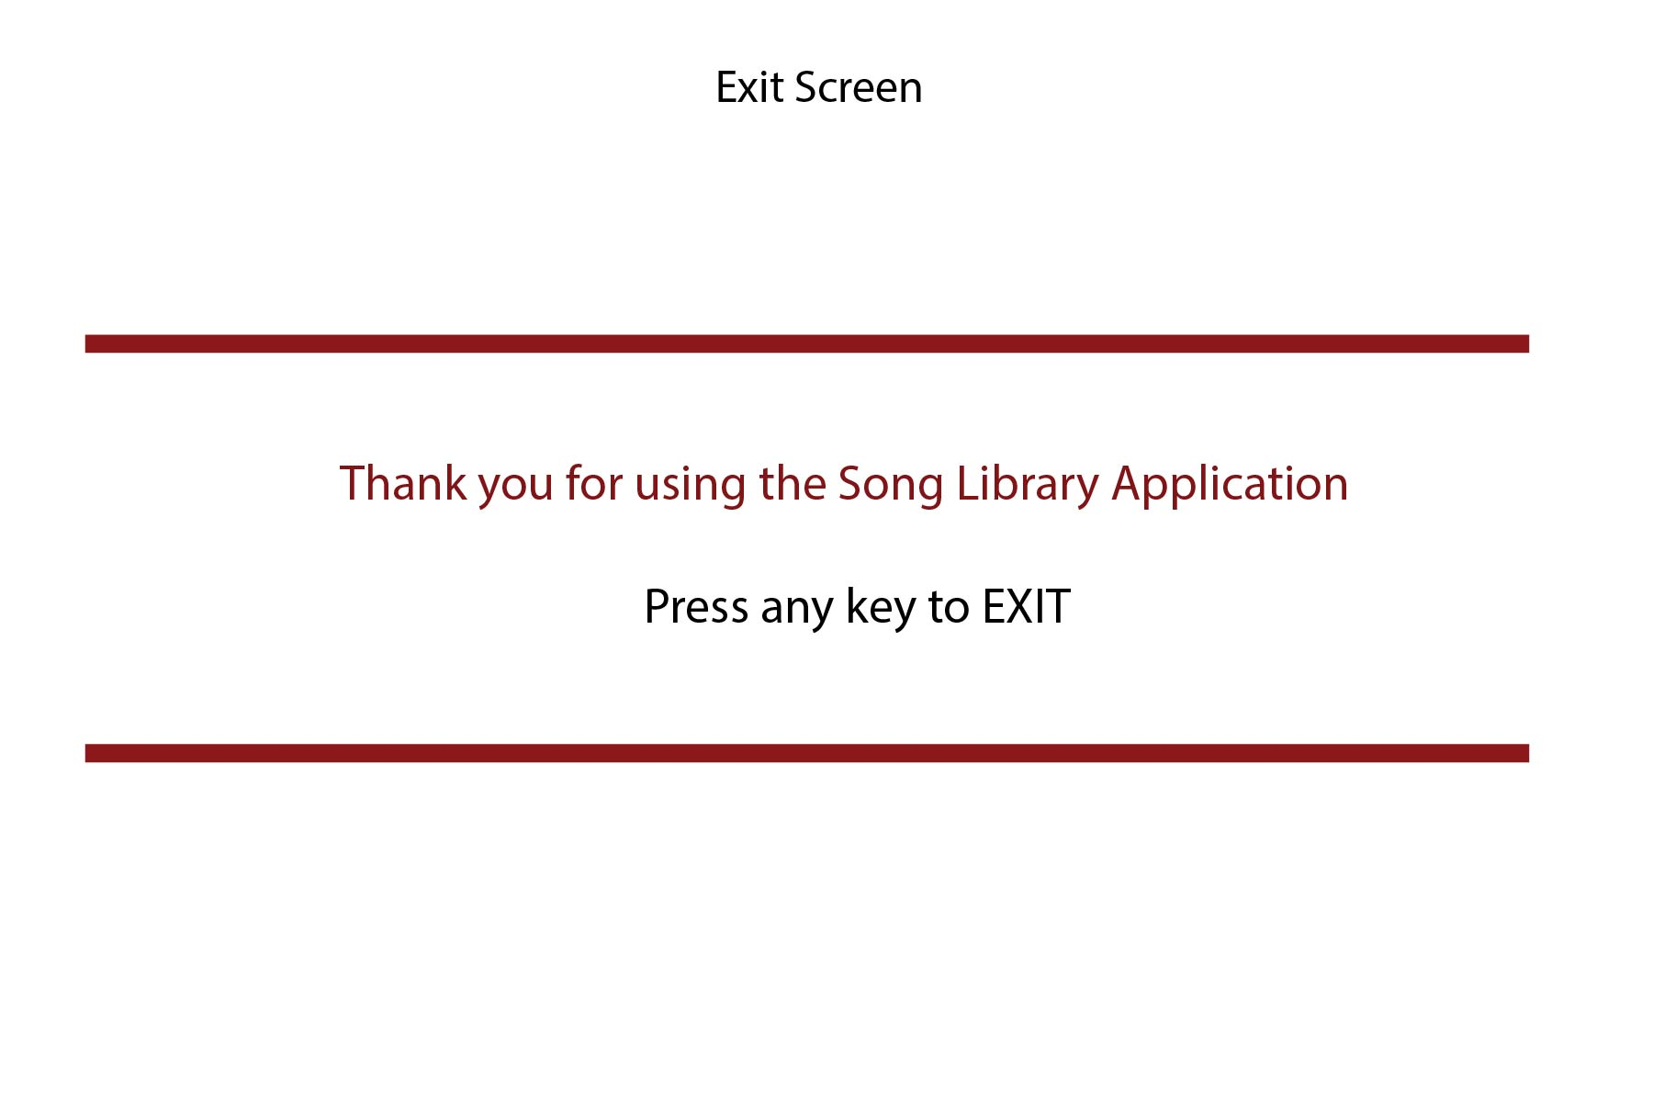

#### Development Environment

##### Development Environment: Visual Studio

##### Description of Persistence: XML

##### Location of Persistence: Local

##### Design Pattern: MVC

##### Target Platform: Console

##### Discussion of the Development Pattern: